July 2, 2020

The Honorable Jerry Hill
Chair, Senate Committee on Labor, Public Employment & Retirement
State Capitol
Sacramento, CA 95814

RE: AB 1993 (Kamlager) – IHSS Unemployment and Disability Insurance
Support

Dear Senator Hill:

The California Association of Public Authorities is in support of AB 1993, by Assembly Member Kamlager, which would extend eligibility for Unemployment Insurance (UI) to parent and spouse providers of In-Home Supportive Services (IHSS) and Waiver Personal Care Services (WPCS). CAPA is a non-profit association comprised of the IHSS Public Authorities in California created to improve the IHSS program in California.

Direct care workers in nursing care facilities typically receive unemployment benefits, some type of pension benefit and Social Security income when they retire. In contrast, home care workers who are the spouse or parent of the consumer are excluded from both Social Security and Unemployment Insurance benefits.

According to the Internal Revenue Service, there are specific employees and employment situations which are exempt from the withholding and payment of employment taxes. IRS Code Sections 3121 (b)(3)(B) and 3306 (c)(5) provide, in part, that employment for the Federal Insurance Contributions Act (FICA) and the Federal Unemployment Tax Act (FUTA) purposes shall not include services performed by an individual in the employ of this/her child or spouse. Therefore, compensation for work performed by IHSS providers caring for their child or spouse are specifically exempt from FICA and FUTA.

Because of these federal laws, individuals who provide services through the state’s IHSS program to their child or spouse are not allowed to contribute towards Social Security, Medicare, or state Unemployment Insurance (UI). This means that when they retire, if they become disabled, or if they lose their jobs, they do not have access to our nation’s most critical programs for seniors and the uninsured. This has resulted in significant economic hardship for IHSS providers who are at or near retirement age.

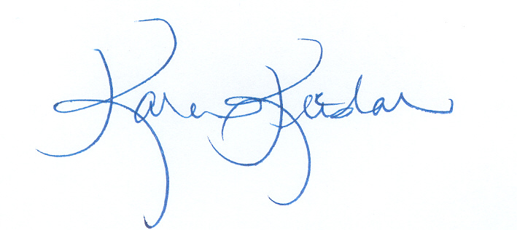
CAPA is in support of AB 1993 to provide unemployment insurance benefits to parent and spouse providers of IHSS. We respectfully urge your “aye” vote.

Sincerely,

Karen Keeslar,
CAPA Executive Director

cc: Members and consultants, Senate Committee on Labor, Public Employment & Retirement
Assembly Member Kamlager

