July 2, 2020
The Honorable Bill Dodd
Chair, Senate Governmental Organization Committee
State Capitol
Sacramento, CA 95814
RE: AB 2047 (Aguiar-Curry) – Emergency response: Alzheimer’s disease and dementia
As amended May 7, 2020
SUPPORT
Dear Senator Dodd:
The California Association of Public Authorities for IHSS (CAPA) supports AB 2047, by Assembly Member Aguiar-Curry, to respond to the COVID-19 crisis by ensuring that all counties address the unique needs of individuals with Alzheimer’s disease and dementia in their emergency response during the next plan update.
COVID-19 has created unique challenges those living with Alzheimer’s and dementia. They depend on a network of caregiving services that have been significantly impacted by the statewide stay-at-home order, and within the broader community of individuals with dementia, individuals who live alone are particularly at risk. Based on the March 2020 Alzheimer’s Association Facts and Figures report, we know that approximately one in four individuals with cognitive impairment lives alone, leaving many without resources they depend upon.
Current state law requires counties to integrate the access and functional needs population into its emergency plan, upon the next update to these plans. However, current law does not require planning for emergency shelter-in-place orders, nor does it explicitly acknowledge the 690,000 individuals in our state living with Alzheimer’s and dementia today - a population projected to increase by 21.7% in the next five years.
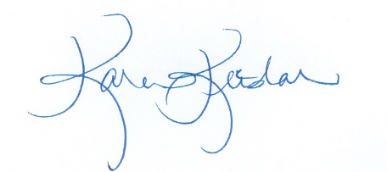
AB 2047 will ensure that county emergency plans account for this vulnerable population and take into consideration the difference between sheltering in place orders and other emergency directives. For these reasons, CAPA supports AB 2047 and respectfully asks for your support of this important legislation.
Sincerely,
Karen Keeslar, CAPA Executive Director

Cc: Members and consultants, Senate Governmental Organization Committee
Assembly Member Aguiar-Curry

