June 23, 2020

The Honorable Melissa Hurtado
Chair, Senate Human Services Committee
State Capitol
Sacramento, CA 95814

RE: AB 2387 (Grayson) – IHSS: Needs Assessments
Support

Dear Senator Hurtado:

The California Association of Public Authorities is in support of AB 2387, by Assembly Member Grayson, to allow telephonic annual In-Home Supportive Services (IHSS) reassessments when a client meets criteria consistent with variable assessment guidelines. CAPA is a non-profit association comprised of the IHSS Public Authorities in California created to improve the IHSS program in California.

The IHSS program provides personal care and domestic services to approximately 620,000 individuals who are aged, blind or have disabilities, which allow these individuals to live safely at home rather than in unnecessary, not desired and more expensive out-of-home placement facilities. IHSS is a foundational part of California’s long-term services and support system, serving as a cost-effective alternative to institutional care. IHSS is the largest personal care services program in the United States, and has been serving people with disabilities, including seniors, since the 1970s.

In June 2019, Governor Newsom signed as Executive Order to create a Master Plan on Aging and established the Long-Term Services and Supports Subcommittee to identify policy opportunities related to California’s long-term services and supports system. The Long-Term Services and Supports Subcommittee was required to submit a report in March 2020 to provide input on LTSS including institutional and home and community-based services, including In-Home Supportive Services (IHSS); LTSS access and quality; workforce labor supply and retention; family caregivers; information & referral systems; LTSS financing; and recommendations to stabilize LTSS.

The LTSS Subcommittee report contains recommendations to simplify IHSS program administration. Key among those recommendations is to, “simplify and improve the functional needs assessments while ensuring individual need is reflected and allow for simple re-determinations for recipients with stable conditions.”

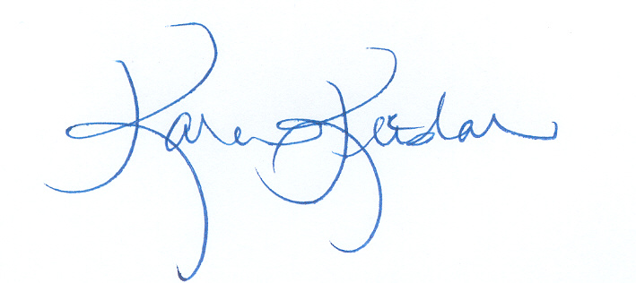
AB 2387 would accomplish that goal by allowing counties to perform reassessments by telephone for consumers with stable conditions. CAPA is in support of AB 2387 to provide greater flexibility to counties for IHSS program administration. We respectfully urge your “aye” vote.

Sincerely,

Karen Keeslar,
CAPA Executive Director

cc: Members and consultants, Senate Human Services Committee
Assembly Member Grayson
Elizabeth Dondi, Contra Costa IHSS Public Authority

