July 2,2020

The Honorable Eloise Reyes
Chair, Assembly Human Services Committee
State Capitol
Sacramento, CA 95814

RE: SB 596 (Stern) – IHSS: Higher Energy Allowance
Support
Dear Assembly Member Reyes:
The California Association of Public Authorities for IHSS (CAPA) is in support of SB 596, by Senator Stern, which would require county human services agencies to, using existing materials, inform each applicant for IHSS benefits, when their initial application is submitted that the applicant may be eligible to receive a higher energy allowance and any advanced notifications that may be provided by a public utility when the public utility plans to deenergize portions of the electrical distribution system or in an emergency.

Electric and gas customers with certain qualifying medical conditions or who use specified medical devices may qualify for utility medical baseline programs. Those enrolled in medical baseline programs not only receive lower energy rates, but they also receive additional notifications of potential utility PSPS events. Residents with medical needs often require advanced and additional notification of power loss to avoid potentially life-threatening conditions. Unfortunately, utility medical baseline programs comprise only a portion of the medically sensitive population. For example, the Los Angeles Department of Public Health recently observed that while there were 491 medical baseline customers on 26 Southern California Edison circuits that were shut down during October 2019, there were over 1,400 Medicare beneficiaries relying on electricity-dependent medical equipment on those circuits. To bridge that gap between medical baseline enrollees and the larger population of medically sensitive Californians, the California Public Utilities Commission’s recent PSPS guidelines (Decision 19-05-042) required electrical utilities to identify access and functional needs (AFN) populations within their customer bases and expand registration for their medical baseline programs in advance of the 2019 fire season. Enrollment in the medical baseline program is even more important because last year’s Senate Bill 167 (Dodd) requires electrical utilities to mitigate PSPS impacts on medical baseline customers, which may include the deployment of backup electrical resources or the provision of financial assistance for those purposes. RCRC supports ensuring that medical baseline customers and other medically sensitive populations receive adequate notifications of PSPS events and mitigation of their impacts.

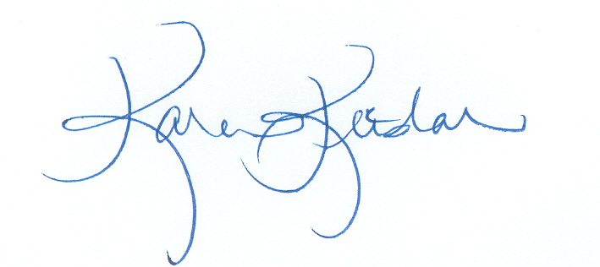
CAPA believes increasing IHSS consumer participation in medical baseline programs will promote the safety of our residents and avoid the need to respond to as many PSPS-related medical emergencies as were experienced during the 2019 PSPS events. For these reasons, CAPA respectfully requests an “aye” vote on SB 596 to require county human services agencies to inform IHSS applicants about medical baseline programs.

Sincerely,

Karen Keeslar,
CAPA Executive Director

Cc: Members and consultants, Senate Appropriations Committee

