July 2,2020

The Honorable Chris Holden
Chair, Assembly Utilities & Energy Committee
State Capitol
Sacramento, CA 95814

RE: SB 801 (Glazer) – Backup Electrical Resources: PSPS events
Support
Dear Assembly Member Holden:
The California Association of Public Authorities for IHSS (CAPA) is in support of SB 801, by Senator Glazer, would require utilities to do more to help medically vulnerable people survive a planned power outage by providing back-up battery packs to all customers whose lives would be endangered by an extended, deliberate power outage. More specifically, this would require an electrical corporation to deploy backup electrical resources or provide financial assistance for backup electrical resources to a customer receiving a medical baseline allowance if the customer meets specified conditions and the customer is located in a high fire threat district. Electrical corporation would also be required to develop its program to provide backup electrical resources in consultation with community disability rights groups or other local disability rights advocates.

Electric and gas customers with certain qualifying medical conditions or who use specified medical devices may qualify for utility medical baseline programs. Those enrolled in medical baseline programs not only receive lower energy rates, but they also receive additional notifications of potential utility PSPS events.

In the months of September through November 2019, there were massive preemptive power shutoffs in approximately 34 counties by Pacific Gas & Electric Company (PG&E), Southern California Edison (SCE), and San Diego Gas & Electric (SDG&E). The power shutoffs created serious risks for many medically fragile older adults and people with disabilities who rely on electricity for critical medical needs — everything from keeping their insulin refrigerated to running motorized wheelchairs or breathing machines.

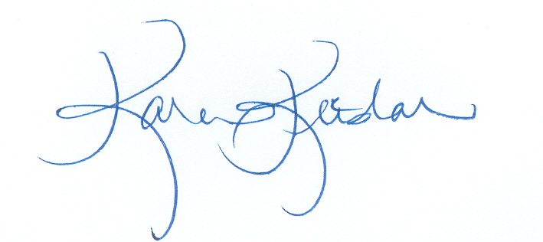
By requiring electrical corporations to provide resources for their customers that rely on life-saving devices, this bill protects the most vulnerable Californians. SB 801 ensures that medical baseline customers that rely on electrically powered medical devices, or need refrigerated medications, will not be put at risk during PSPS events. For these reasons, CAPA respectfully requests an “aye” vote on SB 801.

Sincerely,

Karen Keeslar,
CAPA Executive Director

Cc: Members and consultants, Assembly Utilities and Energy Committee
Senator Glazer

