July 2,2020

The Honorable Chris Holden
Chair, Assembly Utilities & Energy Committee
State Capitol
Sacramento, CA 95814

RE: SB 862 (Dodd) – Planned power outage: public safety
Co-Sponsor
Dear Assembly Member Holden:
The California Association of Public Authorities for IHSS (CAPA) is is pleased to co-sponsor SB 862 by Senator Dodd. This bill expands on existing law requiring utilities to provide for customers with access and functional needs before commencing a Public Safety Power Shutoff (PSPS). Also, SB 862 makes clear that such de-energizations are eligible for emergency declarations, freeing financial assistance for local government under the Emergency Services Act.

In the months of September through November 2019, there were massive preemptive power shutoffs in approximately 34 counties by Pacific Gas & Electric Company (PG&E), Southern California Edison (SCE), and San Diego Gas & Electric (SDG&E). The shutoffs affected millions of Californians. While the duration and frequency of the power shutoff events varied by, and within, each utility service territory, in many of the circumstances the power was off for multiple days, in some cases over a week at a time.

The power shutoffs created serious risks for many medically fragile older adults and people with disabilities who rely on electricity for critical medical needs — everything from keeping their insulin refrigerated to running motorized wheelchairs or breathing machines. And, it’s not just people with obvious medical needs who were at risk during the outages. Low-income households faced hunger and financial crisis as the food in their refrigerators spoiled. People who rely on elevators were trapped or had to be hand-carried from upper floor apartments.

In preparation for and during the PSPS events, Public Authority staff assisted counties to contact and support In-Home Supportive Services (IHSS) consumers with electrical-dependent medical devices and other issues. For example, the Sonoma Public Authority Director worked for many days out of the Sonoma Emergency Operations Center; their IHSS social workers made phone calls and some home visits to all clients identified as urgent, critical, and moderate in the affected power outage area. They also did phone calls and some home visits to about 1,400 individuals on the PG&E medical baseline program who are not IHSS consumers.

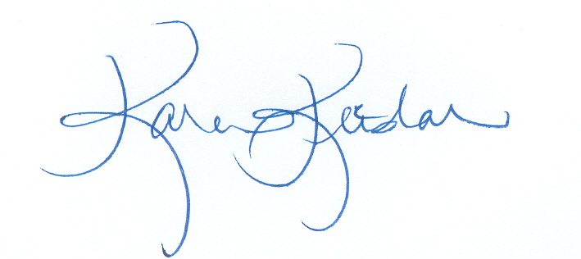
We applaud Senator Dodd’s efforts to require electrical companies to incorporate access and functional needs populations into their decision making to implement Public Safety Power Shutdowns and allow for the provision of backup generators or financial assistance to mitigate the impact of shutoffs. We strongly support the provisions in the bill that allow the state and local governments to declare an emergency related to planned PSPS events would also help mitigate the significant community impacts of PSPS events. CAPA members respectfully request an “aye” vote on SB 862.

Sincerely,

Karen Keeslar,
CAPA Executive Director

Cc: Members and consultants, Assembly Utilities and Energy Committee
Senator Dodd

