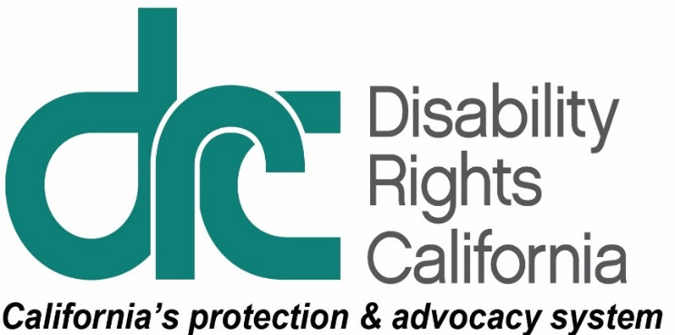
1831 K Street
Sacramento, CA 95811-4114
Tel: (916) 504-5800
TTY: (800) 719-5798
Intake Line: (800) 776-5746
Fax: (916) 504-5807
www.disabilityrightsca.org
FLOOR ALERT
SB 862 (Dodd) - Public Safety Power Shutoffs
Co-sponsor
Disability Rights California (DRC), is pleased to co-sponsor SB 862 and urges your “Aye” vote on this measure that is critical for persons with disabilities and other persons with access and functional needs impacted by power shutoffs.
This past fall there were massive public safety power shutoffs (PSPS) in approximately 34 counties by large investor-owned electric utilities (IOUs) used to reduce the risks of igniting wildfires from the electric utility infrastructure. Those power shutoffs affected the majority of the counties in the state and resulted in mass disruptions that were particularly felt by persons with disabilities and older adults dependent on life-sustaining electrical services and telecommunications. The impacts on these populations include interruptions to electrical operated medical devices such as ventilators and wheelchairs, medication and food storage, maneuverability within housing with elevators or lifts, transportation, and a host of other major challenges.
SB 862 expands on existing law to broaden the PSPS protocol requirements by:
- Clarifying that the term ‘sudden and severe energy shortage’ as used in the Emergency Services Act, includes a PSPS event and specifies that a PSPS event begins at the time a utility issues a notice of a possible upcoming power outage.
- Requiring an IOU, as part of its public safety mitigation protocols, to include protocols that deal specifically with access and functional need individuals, including those individuals who are enrolled in the California Alternative Rates for Energy (CARE) program.
- Requiring an IOU to coordinate with local governments in its service territory to identify sites where community resource centers can be established and ensure the center has a back-up energy source during the time of the PSPS and can be open 24 hours if necessary.
We urge your “aye” vote on SB 862 (Dodd)

